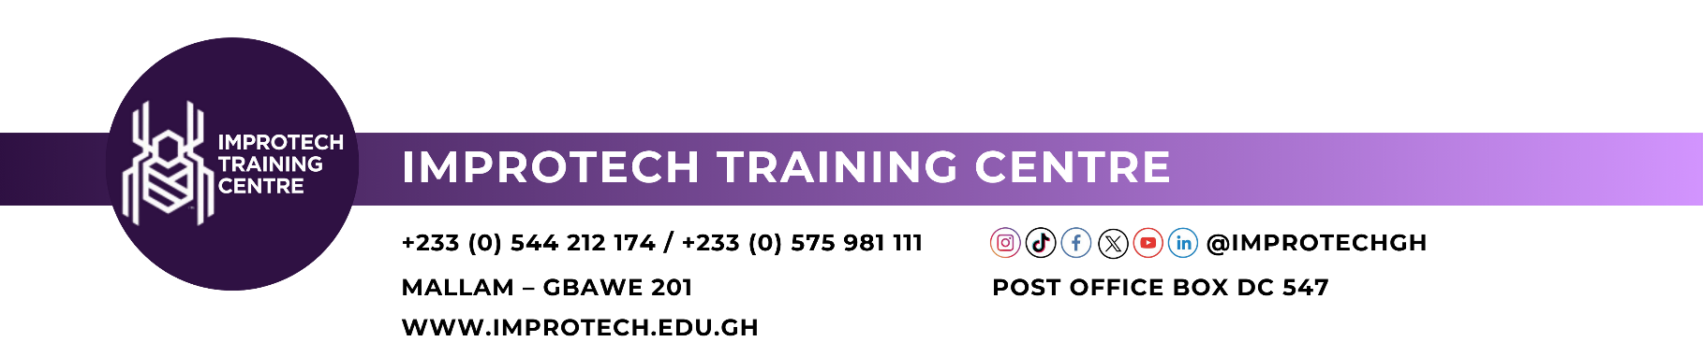
PAYMENT UNDERTAKING AND SALARY DEDUCTION AUTHORIZATION FORM

I, Surname: First Name:
Other Names:
with Staff ID:
of (Company Name):
hereby acknowledge that I have enrolled for the following programme:
Enrolled Programme:
Programme Start Date: Duration:
at a total fee of: GH₵
1. I undertake to pay the full fees in accordance with the instalment plan selected below.
INSTALMENT PAYMENT PLAN (Please tick ✓ one option)
Select | Payment Plan
☐ | Short Courses (less than one year)  (i) 40% before commencement: GH₵ due on  (ii) 30% second instalment: GH₵ due on  (iii) 30% final instalment: GH₵ due on  Note: For 3-month courses, payment must be completed by the second month.
☐ | One-Year Courses  (i) 30% before commencement: GH₵ due on  (ii) Remaining 70% spread over the next nine (9) months in monthly instalments of GH₵ ……………… each, due on the ………… day of each month, from ……………… to ……………….

2. In the event that I fail to make payment as agreed under the selected instalment plan, Improtech Training Centre shall give me seven (7) days' written notice, after which I hereby authorize Improtech Training Centre to contact my employer for payment recovery.
3. I further authorize my employer to deduct the balance outstanding at the due date, as shown on Improtech's statement, from my salary, in amounts not exceeding GH₵ ……………… per month, and pay same directly to Improtech Training Centre.
4. If I leave this employment before full payment, the outstanding balance shall become due immediately and shall remain my personal responsibility.
5. I consent to Improtech Training Centre sharing my fee and payment details with my employer for the sole purpose of recovering the amount owed.
6. This undertaking is subject to Improtech Training Centre's Fees and Refund Policy.
7. This authorization shall remain valid until the full amount is settled.

Student's Details
Phone: Email:
Ghana Card No.:
Signature: Date:

Employer's Acknowledgement
We, the employer named above, acknowledge receipt of this authorization and agree to deduct any outstanding balance notified by Improtech Training Centre from the above-named staff member's salary, within the monthly limit stated in Clause 3, and pay same directly to Improtech Training Centre.
Name of Representative:
Position:
Signature & Stamp: Date:

Improtech Training Centre
Name:
Position:
Signature & Stamp: Date:

